Tree

binary tree : at most 2 child for a root node

complete binary tree :
left side side ko comple honi right se mtlb nhi
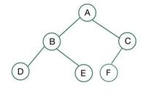

complete and perfect binary tree
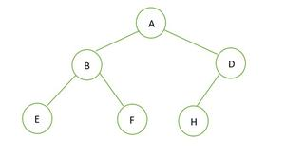
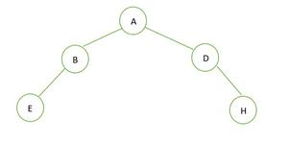
l

comple not a complete bcz left side not fully (left and right node of B)

complete binary tree :
how to find complete binary tree
1. agr root/ node i index pe h to uska left child (2i+1) aur right wala 2i+2

full binary tree
: each node k pass (0 : node) ya fir (2 node )honi chahiye (left right se kuch nhi lena dena h)

